**Sustainable Engineering Management**

# **Introduction**

Sustainable Engineering Management is a multidisciplinary technique that incorporates principles of engineering as well as management with an emphasis on sustainability. It strives in order to design, plan, and manage engineering projects in a manner that lowers their environmental consequence, maximizes resource adequacy, and partakes in social well-being, all while sustaining economic viability.

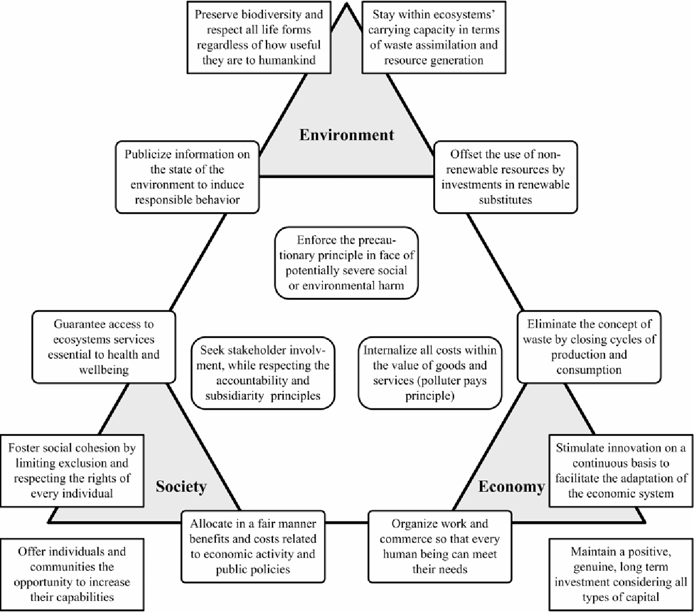

Figure: Sustainable Engineering

## Relevance in the Current Global Scenario

In the contemporary international scenario, Sustainable Engineering Management is of vital importance. With the escalating menaces of resource depletion, climate change, together with environmental degradation, there is an acute demand for sustainable solutions in each and every sector, including engineering. Projects related to the Engineering domain from infrastructure development even to manufacturing processes, have substantial environmental footprints. They consume significant resources, yield waste, and frequently partake in pollution. Thus, integrating sustainability principles into engineering management is critical in order to mitigate these consequences.

Furthermore, consumers together with stakeholders are increasingly challenging businesses in order to indicate their adherence to sustainability. Consequently, Sustainable Engineering Management not only assists in environmental conservation but also delivers a competitive advantage in the market. Moreover, regulatory bodies in the entire world are compressing environmental regulations, making it compulsory for engineering projects in order to concede sustainability actions. Non-compliance can result in big penalties and even cause reputational damage. In the end, Sustainable Engineering Management is fundamental in order to attain the United Nations’ Sustainable Development Goals (SDGs), an international blueprint for a sustainable future. Many of these goals, for example, hygienic water and sanitation, reasonable and clean energy, and sustainable municipalities and communities, directly implicate engineering solutions. Thus, Sustainable Engineering Management is not just a trend but an essential in the contemporary international scenario. It is a strategic procedure that aids the environment, society, and businesses, making it a cornerstone of current engineering practices.

# Brief Literature Review

**Driving Sustainability through engineering management and system engineering**

After the advent of the COVID-19 pandemic, there has been a growth in sustainability efforts in social, economic, and environmental aspects. Challenges like resource overuse, depletion, climate change, etc. have brought this issue to the forefront. By implementing sustainability engineering management and systems engineering practices, organizations have strong frameworks and tools to address the sustainability challenges (Philbin, 2021). From this special issue of contributions, significant information is gained about the role of engineering management and systems engineering in promoting sustainability through studies and innovative solutions in diverse areas and industries.

With the goal of ensuring the effective and profitable completion of engineering projects, engineering management entails managing teams of engineers and projects (Nicholas & Steyn, 2020). Engineering managers are required to ensure that projects are designed in a way that aids in the minimization of their environmental impact. Further, this needs to maximize their sustainability in the long run. This can be achieved by integrating sustainability into the decision-making procedure. On the other hand, system engineering deals with the design and administration of complex systems that may require multiple disciplines and components (Herrera et al. 2020). System engineers can contribute to ensure that the systems they create are effective, environmentally friendly, and enduring by considering sustainability into account throughout the initial stages of system design. By implementing tools like project management, operations management, R&D management, financial analysis, requirements capture, engineering design and modeling, workflow analysis, etc. these challenges can be resolved and opportunities toward sustainability can be encashed.

**Use of Complexity Theory in Engineering Management: Implications for Sustainability**

The article studies the use of complexity theory in engineering management practices for sustainability. In engineering management, CT is adopted for various purposes like supply chain management, product development, project management, etc (Abatecola et al., 2020). It is a multidisciplinary approach that studies Complex adaptive systems and follows their laws, characteristics, and behaviors like emergence and self-organization. CT provides a robust framework to comprehend and manage intricate engineering management systems by considering adaptive strategies, self-organization, and emergence. The CT principles can be implemented to address the uncertainties, drive innovation, and apply sustainability practices in the organization.

**Integrated and Sustainable Net Zero Implementation: The Role of Engineering Management for Sustainability**

These days, there is an urgent need to develop integrated approaches to address the environmental and climate crises. There is a need to develop greener energy systems and redesign production consumption and social awareness (Nunes & Brem, 2024). The article highlights the challenges of phasing out fossil fuels and the role played by organizations to promote sustainability. The importance of quality strategy implementation is also discussed. The author develops questions about optimum integration levels, treatment of unimportant economic activities, and the implementation of artificial intelligence to boost sustainability efforts.

In contrast, Bag (2023) suggested that identifying and evaluating prospects to improve sustainability while decreasing emissions inside the organizations they manage is one of the most important responsibilities assigned to engineering managers in the context of net zero implementation. This could include developing plans for implementing sustainable practices through effect, identifying areas for optimized performance, and auditing existing processes and technological infrastructure.

**Embedding Sustainability in Small and Medium-Size Enterprises**

The article discusses how small and medium enterprises resolve and address sustainability issues using engineering management principles. Organizations embed sustainability efforts like introducing technologies that are efficient in resource utilization, providing sustainable products and services, and upskilling employees through training, skill development, and engagement initiatives (Lozano & Barreiro-Gen, 2021). Technocentric solutions and managerial strategies are also employed to achieve sustainability in organizations. Organizations give priority to optimizing products, operations, and production for sustainability and not to governance and change management. The system elements that are less connected are of major focus. There is a need to increase the training and engagement of employees in sustainability initiatives.

As per the view of Albert (2020), businesses that emphasize sustainability are more inclined to lure in and keep consumers, as people desire increasingly more environmentally friendly goods and services. It is noteworthy that defining specific sustainable objectives, tracking and assessing performance, involving employees and stakeholders in sustainability activities, and iterative refining procedures are pursuant to contributions and outcomes. SMEs can incorporate sustainability into their business processes with the aid of an extensive array of resources, including recommendations from non-profits, associations of industries, and regulatory bodies.

**Sustainable industrial and operation engineering trends and challenges toward Industry 4.0**

In this review, the author discusses sustainable industrial and operations engineering with the advent of Industry 4.0 (Tseng et al., 2021). Industry 4.0 has novel innovations and it fosters automated processes and clever systems that have analytical capabilities. These techniques have allowed organizations to strengthen the field of sustainable industrial and operations engineering. It offers advantages like optimum resource utilization, reduced waste generation, efficient production system, maximization of output with minimum resource allocation, and energy saving.

According to Borg, Gonzi and Borg (2020), the focus on decreasing waste and resource efficiency constitutes one of the primary trends in sustainable industrial and operational engineering. Real-time energy and water consumption monitoring and optimisation are made possible by Industry 4.0 technologies. This results in a major positive impact on the environment and economical savings. Industries can detect operational inefficiencies and implement corrective measures to minimize waste and optimize resource utilization by the implementation of smart sensors, data analytics, and AI algorithms.

# Discussion about Special Attention Areas

## Importance of Sustainable Engineering Management in Engineering Management

Sustainable Engineering Management (SEM) is a crucial characteristic of Engineering Management, as it aligns engineering practices with global sustainability objectives. The significance of SEM is accentuated by several studies. There are effects of mega projects on infrastructure development, emphasizing the role of SEM in influencing a sustainable environment and effective project management. This underscores the significance of SEM in managing large-scale projects to guarantee environmental sustainability and project success (Xiaolong et al., 2021).

Also, it has been signified the importance of SEM in the context of engineering education, indicating that future engineers ought to be provided with knowledge and skills in SEM to contribute to sustainable development (Rampasso et al., 2020). This emphasizes the position of SEM in shaping the future of engineering education and practice.

There is a requirement for a design for a green chemistry future, which is a pivotal element of SEM. This demonstrates the significance of SEM in encouraging sustainable design principles in engineering (Zimmerman et al., 2020). A transformation in the scale of work in engineering for the goal of sustainable development. This indicates that SEM can usher inventive methods in engineering practices, contributing to sustainable development.

## Grand Challenges that Engineering Managers Face in Sustainable Engineering Management

Engineering Managers in Sustainable Engineering Management encounter challenges, for example, balancing financial viability with environmental as well as social concerns, adapting to rapidly developing regulations and technological improvements, and redirecting organizational culture in the direction of sustainability. These challenges implicate explaining upfront sustainability expenses, remaining updated with regulations, constantly adapting to further sustainable technologies, and encouraging collaboration, clarity, and long-term thinking in traditionally structured environments. There have been various challenges in model-driven engineering, which is a climactic aspect of SEM. The intricacy of models and the demand for their authentic interpretation pose momentous challenges for Engineering Managers (Bucchiarone et al., 2020). The significance of individual sustainability in sustainable software engineering. The challenge lies in incorporating individual sustainability into the more comprehensive framework of SEM, guaranteeing that individual efforts align with organizational sustainability purposes (Nazir et al., 2020).

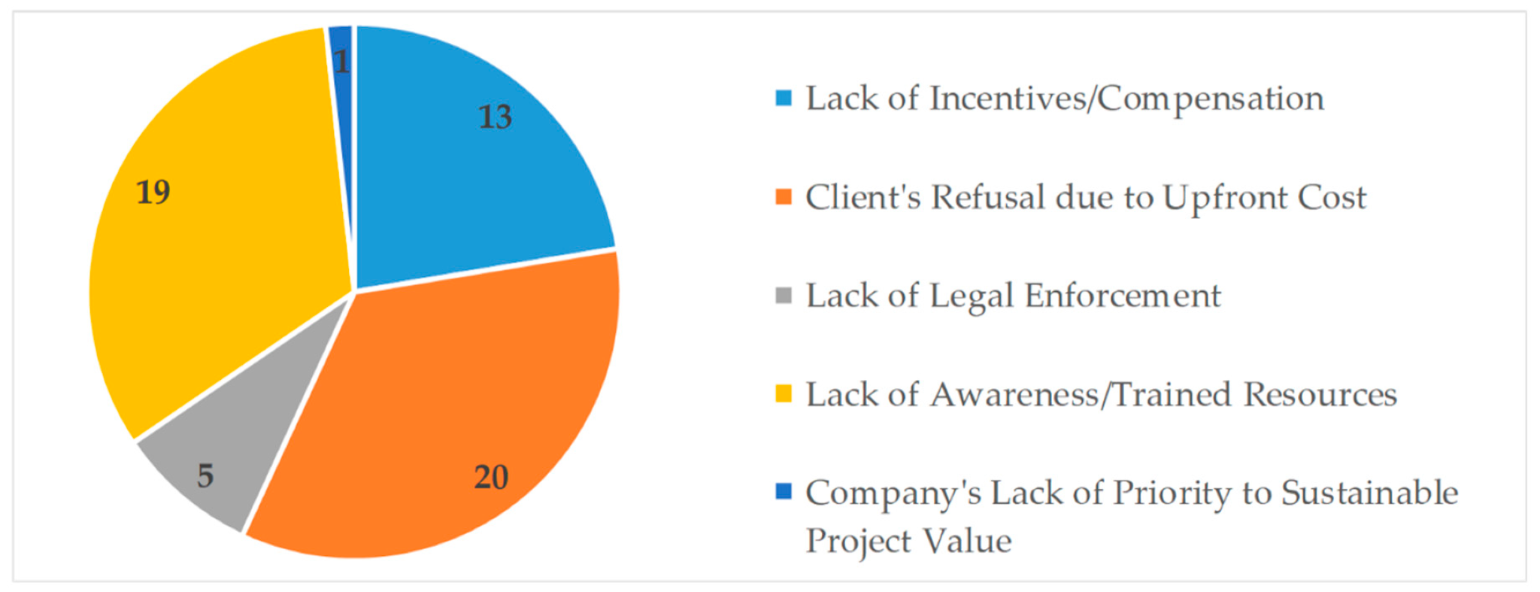

**Figure 1: Obstacles project managers face in implementing sustainable projects**

**Source: (Borg et al., 2020)**

It has also been seen that the Project Manager’s contribution to providing sustainable construction projects. It is evident that there are challenges in case adequate sustainability principles are incorporated into construction project management (Borg et al., 2020). Sustainability in project management practice is crucial (Aghaegbuna et al., 2020). The challenge for Engineering Managers is to entrench sustainability into all facets of project management, from planning to implementation. The multinational sustainability challenges and the characteristics that encourage transformative learning in engineering students. This accentuates the challenge of providing forthcoming engineering managers with the skills and knowledge to guide the intricacies of sustainability (Tien et al., 2020).

## Future Considerations in Sustainable Engineering Management

The hereafter of Sustainable Engineering Management will be shaped by various fundamental considerations. Digital technologies such as AI and IoT will play an increasing role in enriching efficiency and reducing waste. The principles of the circular economy, which incorporate designing for longevity, reuse, as well as recyclability, have become more consequential. Stakeholder engagement, especially involving local communities, is to be highlighted. Thus, education, as well as training, are critical to equip forthcoming engineering managers with the essential skills and knowledge to guide the intricacies of sustainability, including comprehending sustainability principles, regulatory requirements, and the most delinquent sustainable technologies and practices.

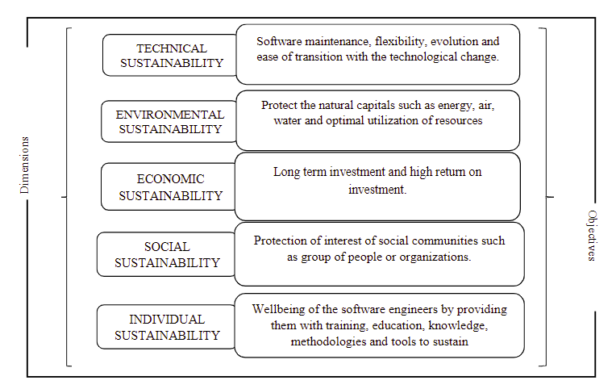

**Figure 2: Dimensions of sustainability in sustainable software engineering**

**Source: (Nazir et al., 2020)**

Engineering Managers in Sustainable Engineering Management experience challenges like balancing economic viability with environmental and social considerations, adapting to rapidly evolving regulations and technological advancements and diverting organizational culture in the direction of sustainability. These challenges incorporate maintaining upfront sustainability expenses, staying updated with restrictions, constantly adapting to the latest sustainable technologies, and encouraging collaboration, transparency, and long-term thinking in traditionally structured environments (Bucchiarone et al., 2020). The complexity of models and the demand for their authentic interpretation pose important challenges for Engineering Managers. The challenge lies in integrating unique sustainability into the more comprehensive framework of SEM, guaranteeing that individual actions align with organizational sustainability goals (Nazir et al., 2020).

The Project Manager’s contribution to providing sustainable construction projects is correspondingly an important aspect. The challenge here is adequately integrating sustainability principles into construction project management (Borg et al., 2020). Sustainability in project management practice is required. The challenge for Engineering Managers is to entrench sustainability into all elements of project management, from planning to implementation (Aghaegbuna et al., 2020). The global sustainability challenges and the characteristics that encourage transformative learning in engineering students emphasize the challenge of providing future engineering managers with the skills and knowledge to navigate the intricacies of sustainability (Tien et al., 2020).

## Strategies for Engineering Management Students to Address Sustainability Challenges

Engineering management students need to combat the challenges regarding sustainability. In today’s scenario, engineering management is concerned with sustainability to ensure a technologically innovative domain (Orlando et al., 2020). It can be stated that the green technology management system has been the driver of a key innovation in the recent era of engineering management.

The students need to incorporate ecological solutions and energy-efficient processes to adhere the environmental regulations. The students can follow sustainable design principles avoiding ready-to-use solutions. They must incorporate management frameworks from environmental, social, and economic perspectives (Orlando et al., 2020). Through the sustainable design principles, the students should minimize the use of non-renewable resources and develop effective waste management techniques. The global sustainability challenges need to be addressed where legal enforcement should be considered vital. The engineering management students should be aware of the sustainable solutions ensuring that the sustainable efforts align with the organizational goals and objectives.

For achieving technical sustainability, the technical skills of the students need to be efficient enough to reduce carbon footprint in organizations facilitating long-term business profitability. The students should utilize sustainable materials for engineering project management. The infrastructure development and the technological synergy should facilitate social, environmental, and economic profitability. Resource utilization should be prioritized by engineering management students. For effective sustainable engineering management processes, efficiency must be gained in strategic decision-making for preventing pollution and life cycle thinking (studysmarter.co.uk, 2024). Several methods can be used for achieving sustainability including Life Cycle Assessment (LCA), Material Flow Analysis (MFA), system thinking, etc.

The students should develop eco-friendly technologies that are capable of enhancing resource utilization and minimizing waste. Cost should also be minimized and the infrastructure developed should be resilient. They should focus on developing environment-friendly engineering solutions. The main aim of the students should be the conservation of energy and reducing the utilization of non-renewable sources. The engineering projects should ensure sustainable engineering management processes.

The sustainability challenges can be combatted through developing economic feasibility as well as technical applicability (Schellenberg et al., 2020). The students must develop proper infrastructure for treatment solutions through engineering management techniques ensuring proper sanitation, upgrading the water quality, and treating wastewater through strategic means. Socio-ecological innovation should be ensured to gain resource efficiency and socio-economic outcomes. As engineering management has been a vital aspect of sustainable measures, the ecological challenges must be dealt with properly through the innovation management system.

# Conclusion

Sustainable engineering management has been a vital concern in managing engineering projects through environmental, economic, and social implications. Sustainability should be incorporated in engineering management processes to reduce the harmful environmental consequences facilitating resource adequacy and social wellbeing. Although organizations face issues regarding sustainable engineering management practices, government initiatives have aided the system with an international blueprint. The UN SDGs have come forward with sustainable goals that can implicate engineering solutions as well. In organizations, project management tools need to be incorporated with sustainable management systems to reduce complexity in engineering management. Sustainability should be embedded in every organization whether it is a small-scale or large-scale organization.

# 

# References

Xiaolong, T., Gull, N., Iqbal, S., Asghar, M., Nawaz, A., Albasher, G., ... & Maqsoom, A. (2021). Exploring and validating the effects of mega projects on infrastructure development influencing sustainable environment and project management. *Frontiers in Psychology*, *12*, 663199.

Rampasso, I., Quelhas, O., Anholon, R., Pereira, M., Miranda, J., & Alvarenga, W. (2020). Engineering Education for Sustainable Development: Evaluation Criteria for Brazilian Context. *Sustainability*. <https://doi.org/10.3390/su12103947>.

Zimmerman, J., Anastas, P., Erythropel, H., & Leitner, W. (2020). Designing for a green chemistry future. *Science*, 367, 397 - 400. <https://doi.org/10.1126/science.aay3060>.

Bucchiarone, A., Cabot, J., Paige, R. F., & Pierantonio, A. (2020). Grand challenges in model-driven engineering: an analysis of the state of the research. *Software and Systems Modeling*, *19*, 5-13.

Nazir, S., Fatima, N., Chuprat, S., Sarkan, H., Nurulhuda, F., & Sjarif, N. (2020). Sustainable Software Engineering:A Perspective of Individual Sustainability. *International Journal on Advanced Science, Engineering and Information Technology*, 10, 676-683. <https://doi.org/10.18517/ijaseit.10.2.10190>.

Borg, R., Gonzi, R., & Borg, S. (2020). Building Sustainably: A Pilot Study on the Project Manager’s Contribution in Delivering Sustainable Construction Projects—A Maltese and International Perspective. *Sustainability*. <https://doi.org/10.3390/su122310162>.

Aghaegbuna, O., Tasmiyah, C., Zanoxolo, B., & Nikiwe, M. (2020). Sustainability in Project Management Practice. *MATEC Web of Conferences*. https://doi.org/10.1051/matecconf/202031202015.Tien, D., Namasivayam, S., & Ponniah, L. (2020). Addressing global sustainability challenges: a qualitative study on factors that promote transformative learning in engineering students. *SN Applied Sciences*, 2, 1-14. <https://doi.org/10.1007/s42452-020-3158-5>.

Vrchota, J., Řehoř, P., Maříková, M., & Pech, M. (2020). Critical Success Factors of the Project Management in Relation to Industry 4.0 for Sustainability of Projects. *Sustainability*. <https://doi.org/10.3390/su13010281>.

Abatecola, G., & Surace, A. (2020). Discussing the use of complexity theory in engineering management: Implications for sustainability. Sustainability, 12(24), 10629.

Lozano, R., & Barreiro-Gen, M. (2021). Embedding sustainability in small and medium-size enterprises: Experiences from Sweden. IEEE Engineering Management Review, 50(1), 211-219.

Nunes, B., & Brem, A. (2024). Editorial Integrated and Sustainable Net Zero Implementation: The Role of Engineering Management for Sustainability. IEEE Engineering Management Review, 52(1), 6-8.

Philbin, S. P. (2021). Driving sustainability through engineering management and systems engineering. Sustainability, 13(12), 6687.

Tseng, M. L., Tran, T. P. T., Ha, H. M., Bui, T. D., & Lim, M. K. (2021). Sustainable industrial and operation engineering trends and challenges Toward Industry 4.0: A data driven analysis. Journal of Industrial and Production Engineering, 38(8), 581-598.

Albert, L. (2020). Sustainable engineering: A comparative study of freshman and senior perspectives. . <https://doi.org/10.18260/1-2--35260>. And

Borg, R., Gonzi, R., & Borg, S. (2020). Building Sustainably: A Pilot Study on the Project Manager’s Contribution in Delivering Sustainable Construction Projects—A Maltese and International Perspective. *Sustainability*. <https://doi.org/10.3390/su122310162>.(eta cite kkora ache)

Nicholas, J. M., & Steyn, H. (2020). *Project management for engineering, business and technology*. Routledge. <http://dx.doi.org/10.4324/9780429297588>

Herrera, M., Pérez-Hernández, M., Kumar Parlikad, A., & Izquierdo, J. (2020). Multi-agent systems and complex networks: Review and applications in systems engineering. *Processes*, *8*(3), 312. <https://doi.org/10.3390/pr8030312>

Bag, S. (2023). From resources to sustainability: a practice-based view of net zero economy implementation in small and medium business-to-business firms. *Benchmarking: An International Journal*. <https://doi.org/10.1108/BIJ-01-2023-0056>

Orlando, B., Ballestra, L. V., Scuotto, V., Pironti, M., & Del Giudice, M. (2020). The impact of R&D investments on eco-innovation: A cross-cultural perspective of green technology management. *IEEE Transactions on Engineering Management*, *69*(5), 2275-2284.

Schellenberg, T., Subramanian, V., Ganeshan, G., Tompkins, D., & Pradeep, R. (2020). Wastewater discharge standards in the evolving context of urban sustainability–The case of India. *Frontiers in Environmental Science*, *8*, 30.

*Engineering*. StudySmarter UK. (2024). https://www.studysmarter.co.uk/explanations/engineering/professional-engineering/sustainable-engineering/#:~:text=Key%20principles%20guiding%20sustainable%20engineering,MFA)%2C%20and%20system%20thinking.